IPS 2020 Biennial Reunion BIENNIAL & PRE & POST TOURS ITINERARIES DRAFT DRAFT DRAFT
(use for website for registrants)
IPS 2020 BIENNIAL LA REUNION ISLAND
Saturday May 23th to Saturday 30th 2020
In 2020, Reunion Island will be pleased to welcome you for the biennial of the IPS. Organized in partnership with Palmeraie-Union society, this event will be one more time an opportunity to gather palm lovers from around the world in an exceptional place. For this 2020 edition, direction towards Reunion Island, a small French island in the southern hemisphere, in the heart of the Indian Ocean, located near Mauritius and the Big Island of Madagascar.
Ideally located in the southwest of the Indian Ocean, the trip in Reunion Island will be an opportunity to participate in the pre and/or post tours that will offer you the possibility to discover Madagascar and/or Mauritius. These 2 destinations are served by daily flights from Reunion (30 minutes flight to Mauritius and 1 hour 30 minutes to Madagascar).
All international airfares, the Réunion-Madagascar and Réunion-Mauritius regional flights and the domestic flights in Madagascar are not included in the tours and will have to be booked separately by participants. These flights can be booked with the Bourbon Voyage travel agency which will be the link with the organization of the biennale in Reunion Island, or book through your own travel agent.

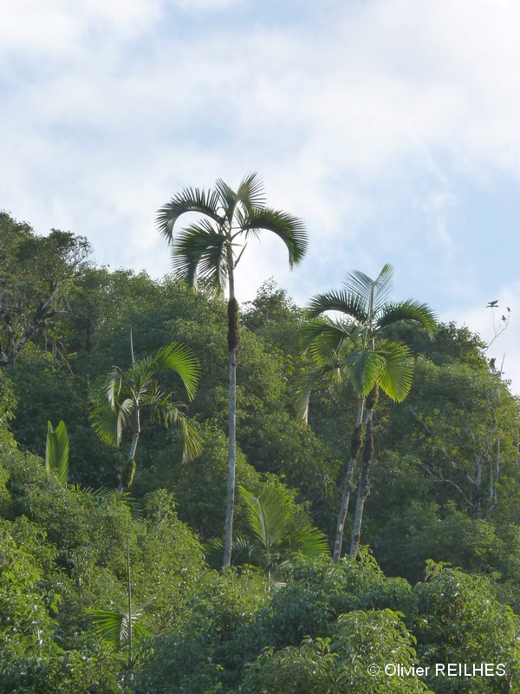

La Reunion island:
Reunion Island is an island of 2500 km² which, due to its subtropical climate and its significant differences in altitude (highest point at 3000 metres), presents very varied landscapes and ecosystems. Its active volcano, the Piton de la Fournaise, regularly experiences lava flows within a volcanic ensemble with an exceptional landscape. The active erosion of the massif has created over time a very rugged terrain consisting of peaks, circuses and ramparts registered with the heritage of UNESCO, a heritage largely protected by the National Park of Reunion which covers 42% of the territory of the island.
Reunion Island is with Mauritius and Rodrigues islands, part of the Mascarene archipelago, a string of volcanic islands far from the continents where a very specific flora with a high rate of endemism has been developed. The diversity of the natural environments of Reunion Island, with very high rainfall and temperature differentials between the east coast with a humid tropical climate and the much drier west coast, and from the coastal fringe to the top of the massifs, is home to very specific vegetation types adapted to these different environments. Reunion Island has more than 350 plants endemic strictly to Reunion Island or more widely to the Mascarene Archipelago. As such, Reunion is recognized as one of the 25 hotspots of global biodiversity. This heritage is particularly fragile and, as elsewhere, has disturbances (urbanization, introduction of exotic species, fires, etc.). Currently, 256 species are considered endangered in Réunion, 30% of its native flora, and 125 of them are critically endangered. Fortunately, the public authorities and many associations are mobilizing for the preservation of this exceptional heritage.
La Reunion’s palms
Palm trees are ubiquitous in public spaces and Reunion gardens and are an integral part of the Creole garden and of the landscapes of the island. Reunion people have for many years introduced many species of palm trees on the island, and many collections, and some of them very old, are exceptionally rich in species diversity of palms. Among them, 6 palm species are endemic to Reunion Island or Mascarenes (in distinct varieties). These species are well known by palm collectors around the world for having been widely disseminated for many years and for being perfectly adapted to many climates and growing media. These species are divided into 4 genera that have developed specifically in the Mascarene archipelago
The genus Acanthophoenix has three species, all naturally present in Reunion island:
- Acanthophoenix crinita is the black palmist of the highlands. Despite poaching, it is still found in large stands in remote, often inaccessible, highland forest areas
- Acanthophoenix rousselii, or Roussel palmist, is present only on the private property of the Roussel family in a place callles le Tampon, hence its name. There are no more than sixty adult individuals.
- Acanthophoenix rubra, or red palmist, has become extremely rare in nature. He is nevertheless considered the king of Reunion palms, being known for the very great taste qualities of his heart, which makes it a widely cultivated palm tree. It’s original habitat is lowland moist forest.
The genus Dictyosperma is known only from one species: Dictyosperma album, which includes several varieties in Reunion, Mauritius and Rodrigues. The variety in Reunion, Dictyosperma album var. album or white palmist, has become very rare in nature. It is a magnificent palm whose legendary resistance to cyclones has earned it the vernacular name of "Hurricane Palm" by Anglo-Saxon people. Its habitat covers semi-dry regions at low and medium altitudes.
The genus Hyophorbe comprises 5 species, only one of which is naturally present in Reunion: Hyophorbe indica is the poisonous palmist or pig palmist. It is quite common in nature. The pulp of the fruit was once consumed by the children. It is found all over the island.
The Latania genus includes three species, one of which is naturally present in Reunion: Latania lontaroides, or red latan, is the emblematic palm of Reunion Island. Its palm leaves are very decorative. It owes its success to its great hardiness and the strong red coloring of its juveniles which is unique in the palm family. Its habitat covers low-lying semi-dry regions.
In Reunion Island, wild palms have become rare, species of the genus Acanthophoenix and Dictyosperma have been decimated for the consumption of their hearts. These species are still largely part of the culinary heritage of the island and are consumed in large quantities, which generates a booming economic activity with the establishment of large plantations and processing units.
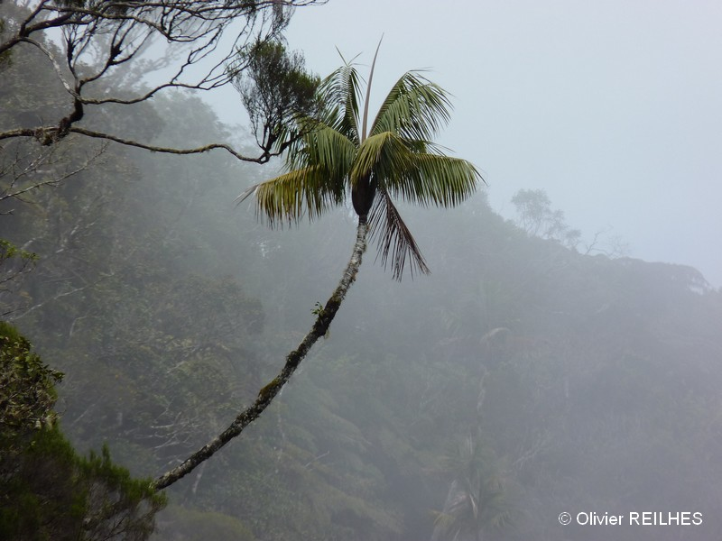

The Biennial program:
Tour Operator: Bourbon Tourisme – refer separate Bourbon Tourisme Terms and Conditions and to IPS Participant Agreement which must both be signed and returned to the IPS to participate in the Reunion Biennial.
Day 0 – Friday, May 22nd: Early arrivals
Board members (and early arrivals) arrive in Reunion and transfer on your own to the hotels in Saint Gilles (Lux and Recif hotels). Dinner on your own.
Note this night is NOT included in the Biennial Package or the Pre Tour packages and must be separately booked by participants either direct through the hotel, or through your travel agent or on line booking service. (see the Extra Night option on the registration page).
Day 1 - Saturday, May 23th: Welcome to Reunion
This is the arrival day for most members and is the Board Meeting day for Directors, welcome dinner.
You will be met at the airport of Saint-Denis de la Reunion and transferred by bus to your hotel. The 2 selected hotels (Lux and Recif hotels) are located beachfront in the seaside resort of Saint-Gilles Les Bains on the west coast of the island. You can sit quietly at your hotel and enjoy the free time at the beach (many opportunities for water activities in the lagoon) or take time in the tourist village of Saint-Gilles Les Bains nearby (bars and restaurants along the harbor, shopping, aquarium ...). A welcoming evening will be offered in one of the 2 hotels (welcome speech, presentation of the program and also Palms of Reunion, gourmet buffet).
Day 2 - Sunday May 24th: The volcano and the forest of Bélouve
Breakfast at your hotel for a 7am departure. Participants will be split into 2 groups for 2 half day tours meeting up at Creole restaurant in La Plaine des Caffres for lunch. Dinner on your own
- The volcano la Fournaise
You will reach the center of the island by bus and discover the fantastic landscapes of the Piton de la Fournaise: old vertiginous craters, lunar landscapes and finally a breathtaking view from a promontory on the volcano. You will observe a shrub vegetation very specific to this type of environment. The Piton de la Fournaise is one of the most active volcanoes on the planet due to the frequency of new eruptions (on average one every nine months in the last ten years). With a little luck, you can see an eruption and the lava flows that made it famous.
- The forest of Bélouve:
You will reach by bus the highlands of Reunion where you will discover a "forests of mists" typical of high altitude, composed of tamarins (Acacia heterophylla), tree ferns, lichens, many species of orchids... At Bélouve, the final destination of this trip, you can observe one of the last populations of Black palmist of the highlands (Acanthophoenix crinita) and from there, a vertiginous point of view on the circus of Salazie below. From Bélouve, different options of walks will be proposed to you according to your desires and your physical condition of the moment, the most motivated ones will reach an incredible point of view on the impressive waterfall "the hole of iron".
Day 3 – Monday, May 25th: private gardens of Reunion island & a tour of the island by east coast
Breakfast at your hotel for a 9am departure. The participants will be divided into 3 groups, groups 1 and 2 will spend the day visiting 2 private gardens in rotation, and group 3 will take a tour of the island by east coast. Lunch included. Dinner on your own.
- The private gardens of Reunion
This day will be devoted to the visit of 2 private gardens belonging to 2 collectors of palm trees, Thierry HUBERT, honorary president of Palmeraie-Union Society, and Serge HOAREAU. During these visits you will enjoy the charm of the Creole gardens and the beautiful typical house of la Reunion and you will be impressed by the rich botanical collections of these gardens: A moment of relaxation and conviviality to meet Reunion enthusiasts people who will be delighted to show you their property and share with you their passion for gardens and palm trees.
- The tour of the island by east coast
Departing from St Gilles, you will take a bus for a tour of the island, passing first by the east coast, with stops on some of the classical tourist attractions of Reunion Island in Ste Anne’s Cathedral and East River’s bridge. You will enjoy the beautiful landscapes of sugarcane plantations on the east coast, the wettest coast of the island. Arriving to the south, in the commune of Sainte Rose, you will begin to see the first lava flows then you will make a stop at a remarkable place called “L’Anse des cascades” where you will have lunch into an impressive and very old plantation of red palmists (Acanthophoenix rubra). Following the tour of the island will take us to travel the wild south coast and its many lava flows that have created over time very impressive landscapes where the vegetation gradually reborn. This day of visits will take us to see one of the last wild populations of red latan (Latania lontaroides) on the sea cliffs and will finish with a moment of relaxation on the huge beach of Grand-Anse to enjoy the sunset sun on the Indian Ocean. Back to St Gilles by west Coast.

Day 4 – Tuesday, May 26th: private gardens of Reunion island & the tour of the island by east coast in rotation
Breakfast at your hotel for a 9am departure. The participants will be divided into 3 groups, groups 1 and 2 will take the tour of the island by east coast as above, and group 3 will spend the day visiting the 2 private gardens as above. Lunch included. Dinner included.

Day 5 - Wednesday, May 27th: Free day
Breakfast at your hotel. This is a free day, book your choice of optional activities. Lunch and dinner on your own. For Directors a further Board Meeting at 7:30pm if required.
During this free day, you will have the choice between staying at the hotel and enjoying a well-deserved relaxation at the pool or at the beach, markets or shopping, or choose from many opportunities for optional sightseeing or activities which will be offered, please book these with your biennial registration: Lava flows excursion, Canoe/Rafting, Volcan Piton de la Fournaise tour, Salazie excursion, Diving Experience, visit Private Gardens of members of Palmeraie -Union, Helicopter tour of the island, refer to the Optional Free Day Tours.

Day 6 - Thursday, May 28th: ​​The Tampon Palm Park
Breakfast at your hotel for staged departure in groups for the 10 minute drive to the park, lunch at the park (in association with la commune du Tampon). Dinner on your own.
During this day, you will enjoy the Palm Park at le Tampon, a vast landscaped park of nearly 10 hectares which presents a unique collection of palm trees of about 40 000 subjects gathering more than 1000 different species, which makes it a world-class botanical garden. This ambitious project initiated in the 90's continues its development with the aim of reaching a surface of 20 ha. You will enjoy all day long the visit of the park and its nursery and you will appreciate the remarkable collections of palms gathered there for many years. The country meal that will be offered to you into the heart of the Palm Park will surely be one of the highlights of this biennale. Finally, in small groups, you will be transferred not far from there for the visit of the only known population of Palmists Roussel (Acanthophoenix rousselii), an endemic species described only in 2006 and which there are only a few dozen individuals left into the wild.
Day 7 - Friday, May 29th: The Wild South
Breakfast at your hotel for 8am departure in 3 or 4 groups. For this last day of your visit, direction to the wild south of the island where several visits will be proposed to you. For the included lunch at a typical creole restaurant, a typical menu will be proposed to you based on heart palms where you will enjoy the Reunion palmists but also other palms grown for their consumption: the Roystonea column palms and the pejibaye (Bactris gasipaes). Gala evening with talks and dinner at the Lux Hotel is included.
- The garden of perfumes and spices
You will discover in this public garden the wonders of Creole garden: a multitude of aromatic plants, four-spice, pepper, nutmeg, cloves at the foot of enormous centenarian mango and litchis trees, and also a rich collection of endemic plants , ferns, orchids, and palm trees of course. All around the garden, you can admire the traditional plantations of vanilla in undergrowth forest.
- The Mare-Longue Forest
Not far from the garden of perfumes and spices, a small stroll will be proposed to you to discover one of the last vestiges of lowland tropical moist forest, locally called “forest of colored woods”. This is one of the richest areas of the island biodiversity that has a significant number of endemic species of trees, ferns, orchids, ... In this beautiful forest, you will meet the poisonous palmist Hyophorbe indica in its natural environment.
- Plantation of red palmists
The wild south is the region of the island where are cultivated large plantations of red palmists (Acanthophoenix rubra). A visit will be offered to you in one of these plantations of red palmists in a breathtaking landscape between sea and mountains.
For lunch, a typical menu will be proposed to you based on heart palms where you will enjoy the Reunion palmists but also other palms grown for their consumption: the Roystonea column palms and the pejibaye (Bactris gasipaes).
In the evening, back to the hotel, you will enjoy a gala evening: conferences, gala dinner and dance party that will end remarkably this magnificent stay in Reunion.
Day 8 - Saturday, May 30th Departure Day
Breakfast at your hotel.
Transfers will be organized to the airport of Saint Denis according to your departure flight schedule.

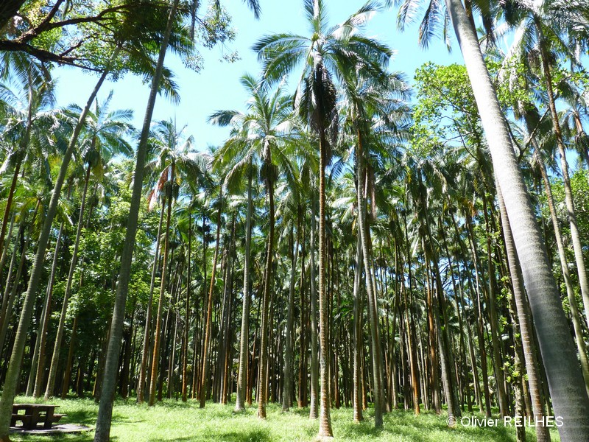
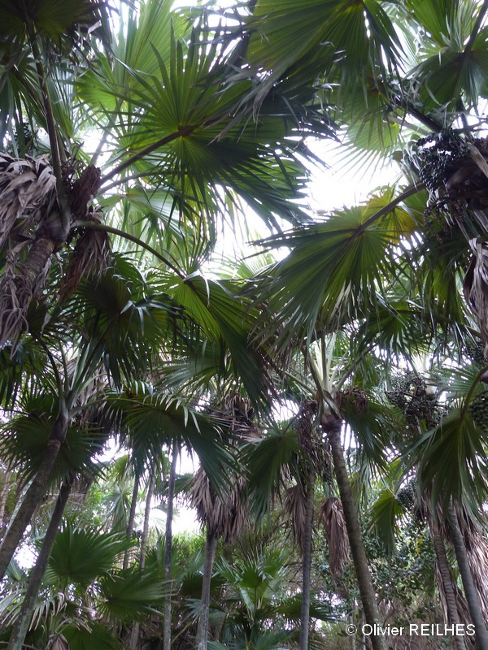

Pré & Post tours Madagascar:

The big island of Madagascar is a center of biodiversity, famous worldwide for its extraordinary landscapes, fauna and amazing flora, ancient culture... it is the place of a great floristic richness especially on palms with 192 species of which the vast majority are endemic. But, the palms of Madagascar are in great danger! Deforestation nibbles the Malagasy forest cover step by step and 83% of Malagasy palm species are now threatened with extinction.

Participating at one of these trips will be a unique opportunity to finally discover Madagascar and its mythical forests populated with rare plants and lemurs. Either one of these trip will be unforgettable. To do this, Palmeraie-Union teams, who know well those places, have prepared for you 5 different options, always in small groups of 6 to 7, 8 or 9 people. These tours have been specially chosen to observe the most interesting places in terms of flora and especially of palm trees.

All these trips are organized in connection with a specialized travel agency based in Madagascar that will guarantee you a welcome and quality support throughout your stay. All accommodation, transfers and visits will be taken into account

Madagascar: Highlands and Andasibe Tour:

Pre Tour Saturday 16th May to Friday 22nd May - 6 nights - 7 days

Tour Operator : Mada Tour Antoka – refer separate Terms and Conditions which must be signed and returned to the IPS to participate in the Madagascar tours.
Min 6 people Max 8 people

Day 1 – Saturday 16th May 2020
Fly La Reunion to Antananarivo.
Overnight in Tana

Day 2 – Sunday 17th May 2020
By road to Ambohitantely
Visit the Ambohitantely Reserve
Back to Tana
Overnight in Tana
Typical forest of Highlands
Dypsis decipiens, Dypsis oropedionis, Ravenea, understory Dypsis,

Day 3 – Monday 18th May 2020
By road to Andasibe
Visit the Analamazaotra Special Reserve
Overnight in Vakona Lodge
Lot of palms: Dypsis sp., Ravenea robustior, understory Dypsis …
Dypsis Black Stem in Vakona Garden
Indri Indri Lemur

Day 4 – Tuesday 19th May 2020
Visit the Maromizaha Reserve
Dypsis sp., pilulifera,
Beccariophoenix madagascariensis, Marojejya insignis, understory Dypsis …
Diademed sifaka Lemur

Day 5 – Wednesday 20th May 2020
Free time in Vakona Lodge (lemur island, Crocodile Park …) or visit another reserve (Vohimana or Mantandia)

Day 6 – Thursday 21st May 2020
Visit Mitsinjo Reserve
Back by road to Tana
Dypsis sp., Ravenea Louvelii, understory Dypsis

Day 7 – Friday 22nd May 2020
Free time in Tana (Tsimbazaza garden …)
Fly Back to La Reunion

INCLUDED
Transfer airport to hotel and back
- Hotel or camp night
- full board accommodation lodge or camping
- Visit picnic and mineral water
- Speed boat or pirogue transfer or trip
- Guide fees
- Entrance permit to parks and reserves
EXCLUDED
- International flight to/from Reunion
- Internal flights in Madagascar
- Accommodation for the night of 22nd May 2020
- Others fees
- Insurance policy

Madagascar: from Andasibe to East Coast Tour:

Post Tour Saturday 30th May to Saturday 5th June 2020 - 6 nights - 7 days

Tour Operator : Mada Tour Antoka – refer separate Terms and Conditions which must be signed and returned to the IPS to participate in the Madagascar tours.

Min 6 people Max 8 people

Day 1- Saturday 30th May 2020
Fly La Reunion to Antananarivo overnight in Tana

Day 2- Sunday 31th May 2020
By road to Andasibe
Visit the Analamazaotra Special Reserve
Overnight in Vakona Lodge
Lot of palms: Dypsis sp., Ravenea robustior, understory Dypsis …
Dypsis Black Stem in Vakona Garden
Indri Indri Lemur

Day 3 – Monday 1st June 2020
Visit the Maromizaha Reserve
Lot of palms: Dypsis sp., pilulifera,
Beccariophoenix madagascariensis, Marojejya insignis, understory Dypsis …
Diademed sifaka Lemur

Day 4 – Tuesday 2nd June 2020
By Road to Foolpointe
Overnight in Analalava Reserve Camp with the chance of seeing the solitary tree of Beccariophoenix fenestralis and possibly the giant Raveneas

Day 5 – Wednesday 3rd June 2020
Visit the Analalava Reserve
Overnight in in Analalava Reserve Camp
Lot of palms: Dypsis carlsmithii, hovomantsina, Marojejya darianii, Ravenea lakatra, Orania trispatha, understory Dypsis …

Day 6 – Thursday 4th June 2020
2nd day of visit the Analalava Reserve
(Or free time in Foolpointe)
Overnight in Foolpointe

Day 7 – Friday 5th June 2020
By road to Tamatave
Fly back to La Reunion

INCLUDED
Transfer airport to hotel and back
- Hotel or camp night
- full board accommodation lodge or camping
- Meals All included except lunches and drinks
- Visit picnic and mineral water
- Speed boat or pirogue transfer or trip
- Guide fees
- Entrance permit to parks and reserves

EXCLUDED
- International flight including to/from Reunion
- Others fees
- Insurance policy

Madagascar: South Coast Tour:

Pre Tour Saturday 16th May to Friday 22nd May - 6 nights - 7 days

Tour Operator : Mada Tour Antoka – refer separate Terms and Conditions
Min 6 people Max 8 people

Day 1 - Saturday 16th May 2020
Fly La Reunion to Antananarivo.
Overnight in Tana

Day 2 - Sunday 17th May 2020
Fly to Ft Dauphin,
Free time in Ft Dauphin
Overnight in Ft Dauphin (Aux Croix du Sud or equivalent)

Day 3 – Monday 18th May 2020
By road to Sainte Luce
Visit Sainte Luce Reserve
Overnight in Sainte Luce
Coastal forest, Ravenea musicalis …

Day 4 – Tuesday 19th May 2020
Drive to Mandena (just north of Ft Dauphin)
Visit Mandena Reserve (QMM Reserve)
Overnight in Ft Dauphin
Coastal Forest

Day 5 – Wednesday 20th May 2020
Drive to Berenty stopping at Andohahela (Dypsis decaryi)
Visit the Berenty Lemur Reserve
Overnight in Berenty Reserve

Day 6 – Thursday 21st May 2020
Return to Ft Dauphin
Overnight in Ft Dauphin

Day 7 - Friday 22nd May 2020
Fly back to Tana (and La Reunion)

INCLUDED
Transfer airport to hotel and back
- Hotel or camp night
- full board accommodation lodge or camping
- Visit picnic and mineral water
- Speed boat or pirogue transfer or trip
- Guide fees
- Entrance permit to parks and reserves
EXCLUDED
- International flights including to/from Reunion
- Internal flights in Madagascar
- Accommodation for the night of 22nd May 2020
- Others fees
- Insurance policy

Madagascar: Expedition on East Coast Tour

Post Tour Saturday 30th May to Saturday 7th June 2020 - 8 nights - 9 days

Tour Operator : Mada Tour Antoka – refer separate Terms and Conditions which must be signed and returned to the IPS to participate in the Madagascar tours.

Min 6 people Max 7 people

Day 1 - Saturday 30th May
Fly La Reunion to Tamatave.
By Road to Foolpointe
Overnight in Analalava Reserve Camp

Day 2 – Sunday 31st May 2020
Visit the Analalava Reserve
Overnight in Analalave Reserve Camp or Foolpointe
Lot of palms: Dypsis carlsmithii, hovomantsina, …, Marojejya darianii, Ravenea lakatra, Orania trispatha, understory Dypsis …

Day 3 – Monday 1st June 2020
2nd day (morning) of visit of the Analalava Reserve
By road to Soanierana Ivongo
Overnight in Soanierana Ivongo
Dypsis bejofo, Marojejya insignis, understory Dypsis …

Day 4 – Tuesday 2nd June 2020
By road To Manompana
4 river crossing on National Road n°5
Visit the Coastal forest of Pointe a Larre
Overnight in Manompana
Coastal forests and landscapes of East Coast, lot of palms

Day 5 – Wednesday 3rd June 2020
Trek to the community forest reserve of Ambodiriana (Canoe and walk)
Visit the Ambodiriana Reserve
Night Walk in Ambodiriana Forest
Overnight in Ambodiriana Forest Camp
Lot of palms: Dypsis, Ravenea, Orania, Satranala, understory Dypsis Lemurs, Uroplatus
Cascades

Day 6 – Thursday 4th June 2020
2nd day of visit the Ambodiriana Reserve
Trek back to Manompana
Overnight in Manompana

Day 7 – Friday 5th June 2020
Drive back to Tamatave

Day 8 – Sunday 6th June 2020
Drive back to Tamatave

Day 9 - Monday 7th June 2020
Fly back to La Reunion

INCLUDED
Transfer airport to hotel and back
- Hotel or camp night
- full board accommodation lodge or camping
- Visit picnic and mineral water
- Speed boat or pirogue transfer or trip
- Guide fees
- Entrance permit to parks and reserves
EXCLUDED
- International flights including to/from Reunion
- Others fees
- Insurance policy

Madagascar : Masoala & Makira Tour :

Pre Tour Friday 15th May to Friday 22nd May - 7 nights - 8 days

Tour Operator : Mada Tour Antoka – refer separate Terms and Conditions which must be signed and returned to the IPS to participate in the Madagascar tours.
Min 6 people Max 8 people

Day 1 – Friday 15th May 2020
Fly La Reunion to Tamatave.
Free time in Tamatave
Overnight in Tamatave

Day 2 – Saturday 16th May 2020
Fly to Maroansetra
Cross by boat the Antongil Bay to Masoala
Trek to Lemurophoenix station
Overnight in Masoala (Chez Arol Lodge)
Lemurophoenix, Beach, fishermen village …

Day 3 – Sunday 17th May 2020
Visit the Masoala National Park
Overnight in Masoala (Chez Arol Lodge)
Coastal forest with lot of palms: Dypsis carlsmithii, Dypsis hovomantsina,… Ravenea, Orania, Satranala, understory Dypsis …
Lemurs

Day 4 – Monday 18th May 2020
Cross by boat the Antongil Bay to Maroansetra
Visit the Nosy-Mangabe island forest reserve or free time in Maroansetra
Overnight in Maroansetra
Rainforest, palms, lemurs, tomato frogs …

Day 5 – Tuesday 19th May 2020
Trek to Makira Forest (run up the river by boat and walk)
Overnight in Makira Forest Camp

Day 6 – Wednesday 20th May 2020
Visit the Makira Forest
Night Walk in the Makira Forest
Overnight in Makira Forest Camp
Upland forest with lot of palms: Dypsis tsaravoasira, Ravenea albicans, Orania ravaka, understory Dypsis…
Silky sifaka lemur, Uroplatus

Day 7 – Thursday 21st May 2020
Back to Maroansetra (walk and boat river)
Overnight in Maroantsetra

Day 8 - Friday 22nd May 2020
Fly to Tamatave and to la Reunion

INCLUDED
- Transfer airport to hotel and back
- Hotel or camp night
- full board accommodation lodge or camping
- Visit picnic and mineral water
- Speed boat or pirogue transfer or trip
- Guide fees
- Entrance permit to parks and reserves
EXCLUDED
- International flights including to/from Reunion
- Internal flights in Madagascar
- Accommodation for the night of 22nd May 2020
- Others fees
- Insurance policy

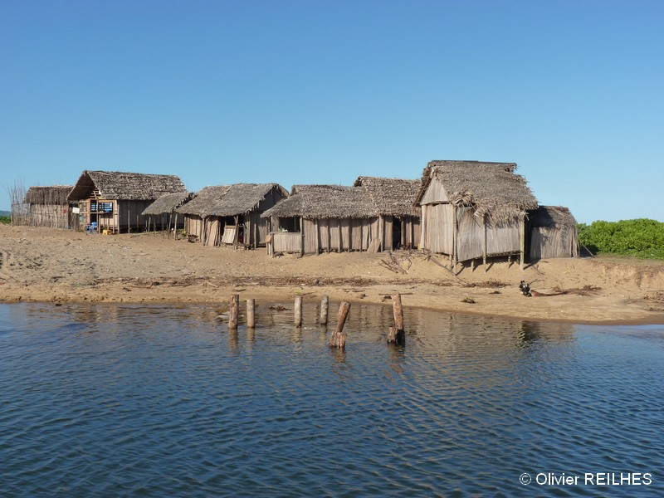

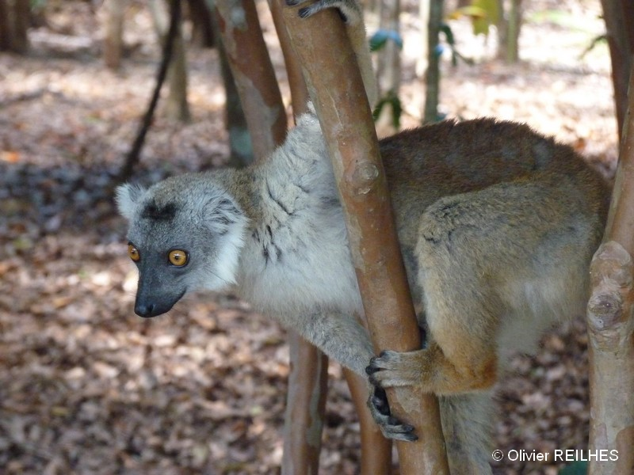

Tour to Mauritius:

Post Tour Sunday 30th May to Saturday 5th June 2020 - 6 nights 7 days

Tour Operator : Bourbon Tourisme – refer separate Bourbon Tourisme Terms and Conditions which must be signed and returned to the IPS to participate in the Mauritius tour.

Min 20 people Max no limit
Only 30 minutes flight from Reunion Island, Mauritius awaits you for a relaxing and exotic stay to discover this very popular island of the Indian Ocean. You will be located in Flic en Flac, a famous seaside resort on the west coast, and you will enjoy a luxury hotel setting on the beach to have a good time. Three days of visit will be on the program. For the other days, according to your desires, a multitude of visits and activities can be proposed to you directly from your hotel (hiking, diving, visits, golf, nautical activities, and sport fishing...).

To do and see (note some of these are included in your 3 full day excursions see the Package inclusions below:
Visit the Black River Gorges National Park where you can take an easy half-day hike, in what remains today of the old mountain forests of Mauritius island. You can observe extremely threatened endemic flora including some of the last specimens of the very rare species of endemic palm trees: Tectiphiala ferox, Acanthophoenix rubra and Hyophorbe vaughanii.
Enjoy the incredible landscapes offered by the Black River Gorges tourist route and you can visit the tourist sites of Chamarel. The Earth of the 7 colors of Chamarel is a famous place where soil presents surprising variations of colors. A little further, you will discover from an impressive promontory an impressive waterfall. At the end of the day, you can visit the Chamarel rum factory and can enjoy some of the best rums on the island.
Visit the town of Curepipe where you can visit its small botanical garden, famous all over the world to present the unique and last specimen of Hyophorbe amaricaulis. You will be impressed by this large palm tree protected in a cage and surely affected to imagine its probable disappearance to come because it has not been able to reproduce.
Visit the famous garden of Pamplemousse. Covering an area of ​​37 hectares, you will discover in this exceptional botanical garden a multitude of species of plants brought there since the 18th century, at the time of Pierre Poivre and the infatuation for acclimation gardens. Palm trees are numerous (95 species present) and often very old, whether they are species of the Mascarenes (Latania, Hyophorbe, ...) Seychelles, but also from all over the world. You will appreciate the old-fashioned charm of this garden by strolling at the edge of the pool ornamented with giant water lilies (Victoria amazonica).

THE HOTEL: LA PIROGUE
Situated along the breath-taking sunset coast and bordered by scintillating turquoise waters, La Pirogue offers guests an incredible four-star experience in paradise. Imbued with authentic and unrivalled Mauritian charm, La Pirogue resembles a traditional fishing village, each bungalow’s thatched roof reminiscent of the unfurled sail of a local fishing boat, from which the resort derives its name. Set amongst a coconut grove and surrounded by lush gardens, this boho-chic hotel boasts a relaxed atmosphere that is still vibrant— perfect for both families and couples alike.
The rooms at La Pirogue are tucked away in individual grounded thatched bungalows that open privately onto the palm grove and the turquoise lagoon. These rooms offer a convivial, cosy and authentically Mauritian atmosphere.
Garden Bungalow: Facing the resort’s lush coconut grove, these rooms offer a convivial and cosy atmosphere in thatched and grounded bungalows with a private patio. Rooms size - 25m2 | LED flat screen TVs with satellite channels in 4 languages | Bathroom with separate bath, shower and toilet | individually controlled air conditioning | Electronic room safes | Complimentary Wi-Fi | Tea and coffee making facilities | Furnished private terrace
Easy access to six restaurants and three bars - an invitation to discover refined international and fusion style cuisine, own signature cocktails and daily sundowners.
- One of the best kids and teens club of the island offering a world of fun and entertainment for kids from 2-11 years and teens from 12-17 years.
- A fully equipped Fitness Centre by Aura and a unique Health and Wellness Tropical Spa by “Cinq Mondes” with its own authentic hammam.
- Complimentary return boat transfer from Pointe Maurice jetty to Ile aux Cerfs Golf Club and daily golf initiation at 11am.
- Complimentary Wi-Fi throughout the resort. • No boundaries to restrict your enjoyment of the facilities of two hotels with five-star sister property at walking distance, Sugar Beach and services of both properties.
THE PACKAGE INCLUDES:
- Standard transfers grouped (airport / hotel / airport) to Mauritius
- Accommodation for 7 nights half board at the hotel LA PIROGUE in Garden Bungalow room ‘s category.
- 1 entrance to La Vanille Park offered per person during the stay (excluding transport)
- 3 Full days excursions :
  - Countryside Mauritius Lunch at La Rhumerie de Chamarel followed by a rum tasting and ending the day with the visit of the Seven Coloured Earth and the Chamarel’s waterfalls. Including: Full day in air-conditioned vehicle + Visit & Lunch of Rhumerie de Chamarel + Rum tasting + 1 drink during lunch (excluding drinks) + entrance fee at Chamarel 7 coloured earth.
  - Curepipe Botanical Garden / visite of Port Louis / Pamplemousses Garden On the top of Trou aux Cerfs, which is an extinct volcano located in Curepipe, you will have a breathtaking panoramic view on most of the Island. Including: Full day in air-conditioned vehicle + Visit of Curepipe Botanical Garden + Visite of Port Louis + Lunch + Beverage package during lunch (Welcome cocktail + ½ Bottle of water+ Coffee) + entrance fee of Pamplemousses Garden. Excluding: The service of a guide to visit the Botanical Garden of Curepipe and the Pamplemousses Garden- Note : There is no guide in the Curepipe Botanical Garden … no guide provided on the site. Note : Pamplemousses Garden : Possibility to rent the service of a guide of the garden , on site .
  - Hiking Black River Gorges The place where you will be dazzled by the abundance of endemic plants which serves as habitat to monkeys and some rare species of birds namely the Paille en Queue, the Cateau Vert and even sometimes , the Crecerelle. Including: Full day in air-conditioned vehicle + Hiking
  - Excluding: Lunch
THE PACKAGE DOES NOT INCLUDE:
- Round-trip flights from REUNION
- Airport and security taxes to date (Adult: 136.43 € on 27 May 2019)
- Drinks and lunches during the whole stay
- Transportation to and from La Vanille nature park
- tips, extras and personal expenses
- Possible readjustment of air taxes
- All that is not mentioned under "the package includes"
FORMALITIES AND SPECIAL CONDITIONS FOR THE MAURITIUS TOUR
- Passport : You are advised to check passport validity requirements
- Health : Check with your travel health professional, remember to bring a first aid kit with your usual medications.
- CANCELLATION: The cancellation by the customer of his trip will entail the following charges:
- More than 180 days before departure: 30% of the total cost of the trip
- From 180 days to 120 days before departure: 40% of the total cost of the trip
- From 120 days to 90 days before departure: 50% of the total cost of the trip
- From 89 days to 46 days before departure: 60% of the total cost of the trip
- From 45 days to 30 days before departure: 80% of the total cost of the trip
- From 30 days to 1 days before departure: 100% of the total cost of the trip
- CONDITION OF REVISION OF PRICES: These prices were established according to the economic conditions in force on May 25, 2019. They cannot be guaranteed in the event of an increase due to carriers linked to the cost of fuel and taxes or in case of large fluctuations of the currency, unit building tariffs. In accordance with the law, we reserve the right to change our prices in case of variations in kerosene prices, exchange rates and taxes. We specify that group pricing is applicable for travellers with identical dates and journeys. Any changes to dates, routes or any component of this offer will be considered a change and will result in a rate adjustment. In accordance with Article L 211-12 of the Code of Tourism the prices provided in the contract are revisable up to 30 days before departure, to take into account variations in the cost of transport, royalties and taxes, exchange rates.

